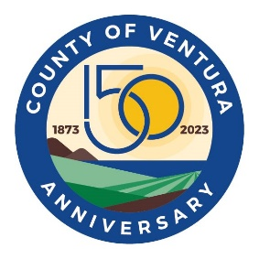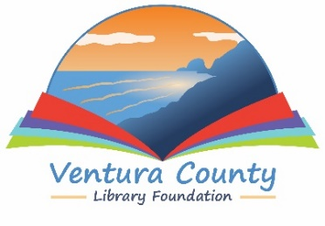

VENTURA COUNTY LIBRARY

5600 Everglades Street, Suite A, Ventura, CA 93003

www.vencolibrary.org

FOR IMMEDIATE RELEASE
August 18, 2023

SUBJECT: Ventura County Celebration of Books –at CSU Channel Islands
CONTACT: Nancy Schram, Library Director, (805) 677-7158

DATE: Saturday, September 30, 2023; 10am-3pm

The Ventura County Celebration of Books will be held on the campus of CSU Channel Islands from 10 am to 3 pm on Saturday, September 30. The event is a celebration of the literary world and everything about books. Both the event and event parking are free and open to the public. All ages are welcome with events for the whole family. The event is presented by the Ventura County Library Foundation, CSU Channel Islands, the CSU Channel Islands John Spoor Broome Library, the Ventura County Library, and the Ventura County Star.
Activities include Story Times for kids presented by CSUCI Early Childhood Studies department and stories will be read in English and Spanish.
Families, CSUCI students and other attendees are invited to bring a blanket and share a picnic on the lawn. Bring your own lunch or purchase food from a local food truck.
Over 40 exhibitors will be on hand to chat with attendees and share information including local authors, government and nonprofit agencies, and local businesses. Local authors and others who would like to host an exhibitor table can visit www.vclibraryfoundation.org for more information and an application. Applications are due by September 5.
Two CSUCI professors will present educational lectures for community members. Dr. Frank Barajas will present “Oxnard Farm Laborers” and Dr. Raul Moreno Campos will present “Salvadorean Politics.”
The Ventura County Library’s 2023 One County, One Book author presentation featuring a conversation with Javier Zamora, author of this year’s community reading title section, Solito: A Memoir, will conclude the day from 2 to 3 pm in the Grand Salon. The author event is free and open to the public and will be moderated by the VC Star.
A special limited capacity ticketed luncheon and author reception with Javier Zamora will be held prior to the author event from Noon to 1:45 pm in the Grand Salon and will feature “A Taste of Central America”. Tickets are required for the author reception that will include lunch, entertainment and dance, a paperback copy of Solito, and book signing with Zamora. Tickets are $75 and can be purchased at www.vclibraryfoundation.org.
The Ventura County Celebration of Books is generously sponsored for the community by Premier America Credit Union, Montecito Bank & Trust, Ventura County Community College District, Mustang Marketing, and First 5 of Ventura County.
To find out about exhibitor and sponsorship opportunities or for more information contact Nancy Schram, Library Director, at (805) 677-7158.
CSU Channel Islands is located at 1 University Drive in Camarillo, CA.

Ventura County Library:
Inspiring our community to explore, discover and connect.
The Ventura County Library is available 24/7 at www.vencolibrary.org.


###

If you would prefer not to receive these event notices in the future, simply reply to this email
with UNSUBSCRIBE in the subject line.

