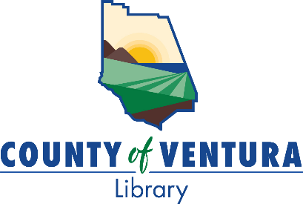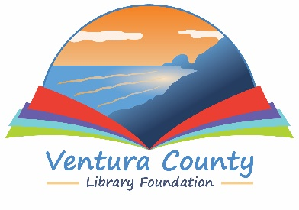

VENTURA COUNTY LIBRARY

5600 Everglades St., Suite A, Ventura, CA 93003

www.vencolibrary.org

FOR IMMEDIATE RELEASE
August 8, 2023

SUBJECT: One County, One Book 2023 – A community reading program – at the Ventura County Library
CONTACT: Nancy Schram, Ventura County Library Director, (805) 256-8535
Ron Solórzano, Regional Librarian, (805) 218-9146

DATE: California Lutheran University Faculty Panel, 7pm on Thursday, September 21, 2023; additional program events available throughout September.

The Ventura County Library is proud to announce its sixth annual One County, One Book community reading program. One County, One Book aims to unite the Ventura County community around a common narrative, spreading interest in and facilitating discussions about the selected book. Throughout September, 2023, people across the county will have a chance to attend discussions and other special events related to the themes of the selection. One County, One Book 2023 is truly a countywide initiative, and aims to spark conversations, foster a stronger sense of community, and promote a love of reading and literature. The 2023 One County, One Book program is sponsored by the Ventura County Library Foundation.
This year’s One County, One Book selection is Solito, by Javier Zamora. Solito is Zamora’s memoir of his migration from El Salvador to the United States at the age of nine. From the official description:
“Solito not only provides an immediate and intimate account of a treacherous and near-impossible journey, but also the miraculous kindness and love delivered at the most unexpected moments. Solito is Javier’s story, but it’s also the story of millions of others who had no choice but to leave home.”

Additional One County, One Book events include a Faculty and Alumni Panel Discussion presented by California Lutheran University. Cal Lutheran will present a panel of professors— Dr. Julia Fogg, Dr. Jamshid Damooei, and Dr. Jose Alfredo Torres—who will talk about border crossings, the criminalization of immigration, and the economic impact of immigrants in Ventura County. This event will take place in Cal Lutheran’s Lundring Events Center at 7pm on Thursday, September 21, 2023. For more information about the panel, contact Michaela Reaves at reaves@CalLutheran.edu or (805) 493-3381.
The Rev. Julia Lambert Fogg is a professor in the Religion Department at California Lutheran University. She specializes in the New Testament, early Christianity, and theologies from the margins; border crossing narratives; and cross-cultural reading practices. Her book, Finding Jesus at the Border: Opening Our Hearts to the Stories of Our Immigrant Neighbors (2020) examines border crossing narratives in the gospels and shows how these narratives are illumed by the experiences of young Latino/a immigrants who cross borders to arrive in Southern California.
Dr. Jamshid Damooei is a professor and Director of the Economics Program and the Executive Director of the Center for Economics of Social Issues (CESI) at California Lutheran University. Prior to joining Cal Lutheran, he served as Senior Economist for the United Nations Development Program (UNDP) and was Director General of the Department of Economic Studies and Policies for the Ministry of Economic Affairs and Finance in Iran. His research analyzes the Ventura region's current economic situation and offers solutions to promote economic development for all workers in the area.
Dr. Jose Alfredo Torres is an Assistant Professor and Program Director for the Criminology and Criminal Justice Program for the Professional Program at California Lutheran University. His research interests focus on the criminalization of immigrants in the United States and the effects of immigration laws on immigrant families. His current work explores people’s experiences within both the criminal justice system and the immigration system in the United States and abroad, specifically the impacts and effects on immigrant and deported fathers in the United States and El Salvador.
To participate in One County, One Book, pick up a copy of Solito from one of our 12 library branches or our Mobile Library. In addition to our regular holdings, beginning in August each library will have an Honor Book Shelf set up with additional copies. You can take one of these special copies to read and return it when you are done, or pass it on to a friend. You can even donate a new copy for others!
The One County, One Book capstone event will be an author presentation by Javier Zamora that will be held as part of the Ventura County Celebration of Books and will take place on September 30 at 2pm on the campus of CSU Channel Islands. The presentation will be in English, with Spanish translation available. The Ventura County Library Foundation is also hosting an author reception, “A Taste of Central America,” prior to the presentation, from noon to 1:45pm. Attendees will enjoy lunch, a complimentary paperback copy of Solito, and a book signing with the author. While the author presentation is free and open to the public, tickets are required for the reception and can be purchased for $75 each at www.vclibraryfoundation.org.
Once you have read the book you will be ready for our September events. Visit our website at www.vencolibrary.org/library-events for more information as programs are scheduled.
For more information about the 2023 One County, One Book program, visit www.vencolibrary.org/ocob or contact Ron Solórzano at ron.solorzano@ventura.org or (805) 218-9146.
The Ventura County Library is available 24/7 at www.vencolibrary.org. Please visit our website for information on the location and hours of the library closest to you.

Ventura County Library:
Inspiring our community to explore, discover and connect.
The Ventura County Library is available 24/7 at www.vencolibrary.org.


Ventura County Library has 12 locations and a Mobile Library
See our hours of service at https://www.vencolibrary.org/locations
###
If you would prefer not to receive these event notices in the future, simply reply to this email
with UNSUBSCRIBE in the subject line.

